

Article Processing Charges (APCs) for Science Advances – How Authors from CRUI Consortium Members Can Apply an Affiliation Discount

Introduction

This document provides an overview for authors on how to apply an affiliation discount for Science Advances, the gold open access journal of the American Association for the Advancement of Science (AAAS). Please note that Science Advances only offers affiliation discounts on APCs to authors affiliated with select institutions. (For more information about Science Advances, see: https://advances.sciencemag.org/.)

How To Preview An APC and Affiliation Discount

During submission. When submitting a paper, the corresponding author(s) has the possibility of viewing the Publication Charges (APC) before submitting.

At the Validate stage (the last stage of Submission), scroll down to the Publication Charges section, and click on View Publication Charges. Follow the steps in
How To Apply An Affiliation Discount to view the APC total and to confirm if the affiliation discount has been applied.:
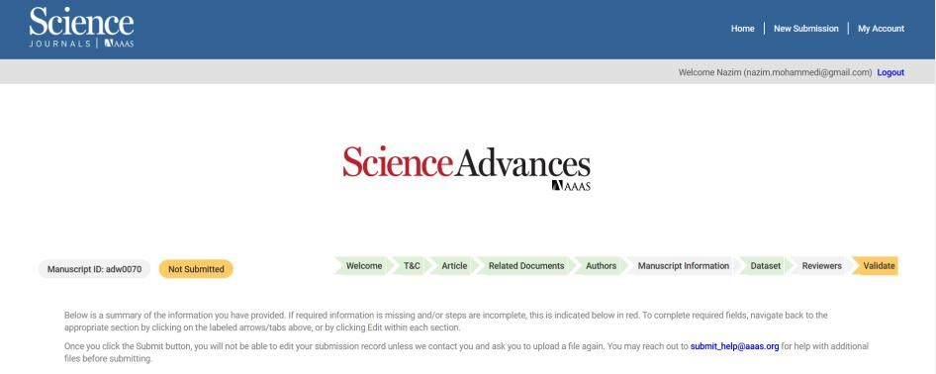

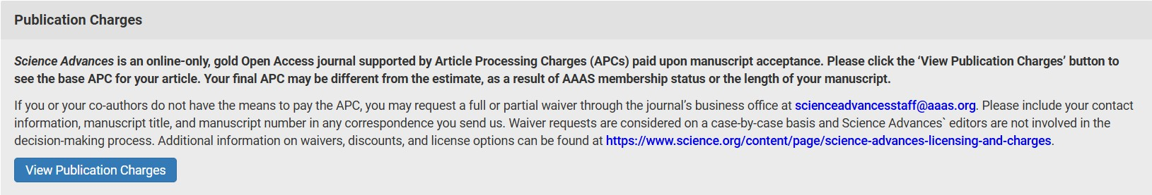

Click on View Publication Charges and follow the steps in “How To Apply An Affiliation Discount”.

How To Apply An Affiliation Discount

- Access the Charge page. Upon provisional acceptance, the corresponding author(s) will receive an email requesting APC payment and providing a link to the charge page on the RightsLink payment platform.

- Select a License and click the “Next” button. Authors must select a publication license for their manuscript. Science Advances offers both CC BY-NC and CC BY licenses. Authors should check with their funding body to see if they are required to publish under a CC BY license.
  - If the discounted affiliation has been entered into the manuscript record in our submission system, the discount will automatically apply.
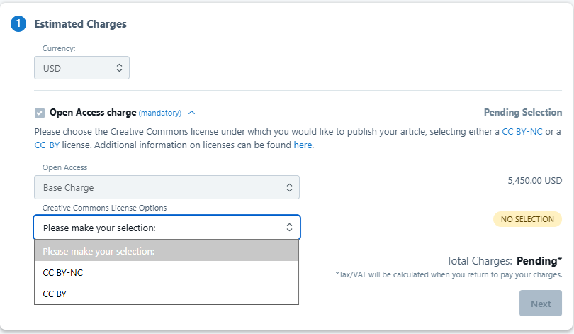

- Select Institution. In the Apply Discounts section, the institution used for an affiliation discount will appear in the “Your Institution” Box. The name that appears is the official Ringgold Organization Name.
  - If the affiliation that appears in the “Your Institution” box is not correct or not triggering a discount, it may simply be deleted and replaced with the correct institution name. Please see section on the manuscript submission system for more information on this.
  - In order for the affiliation discount to correctly apply, the author must select the institution that has the agreement with AAAS that grants them access to journal content, rather than their particular department or sub-body. For example, the author would need to select “Universita degli Studi di Napoli Federico II” rather than “Universita degli Studi di Napoli Federico II Dipartimento di Farmacia”.

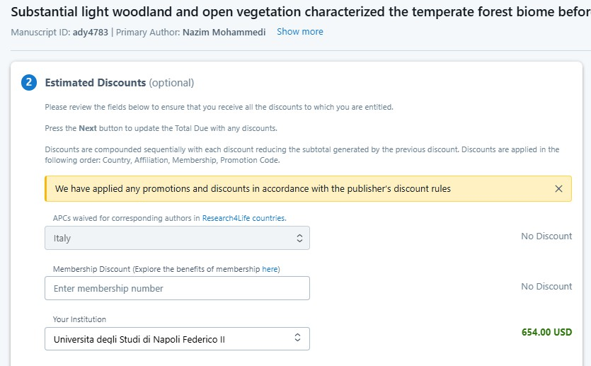

- Apply Discount. Once the appropriate institution name has been located, click the blue “Apply”
button.
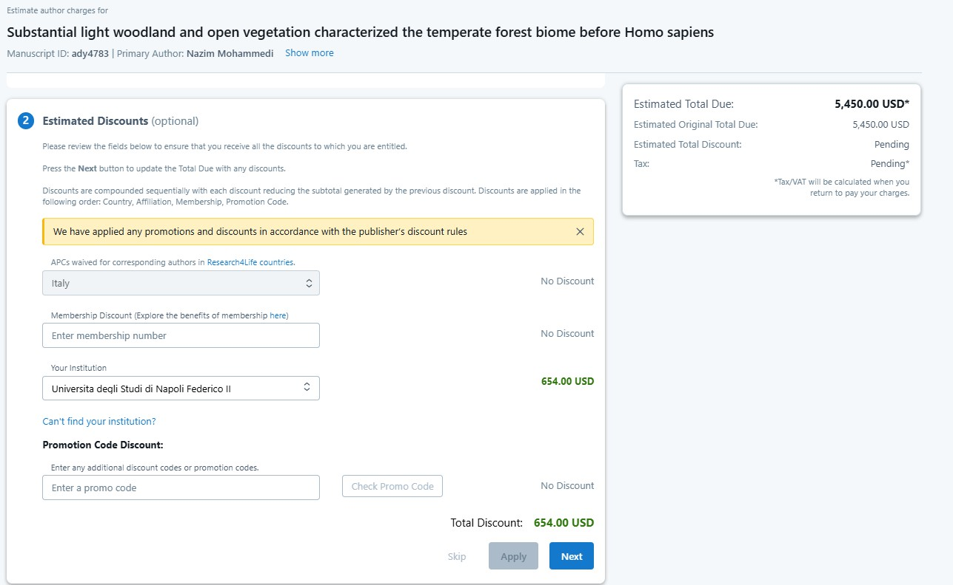

- Confirmation of institutional eligibility. If the institution is eligible for a discount, the
reduction in USD will appear instead of the “No discount” text.

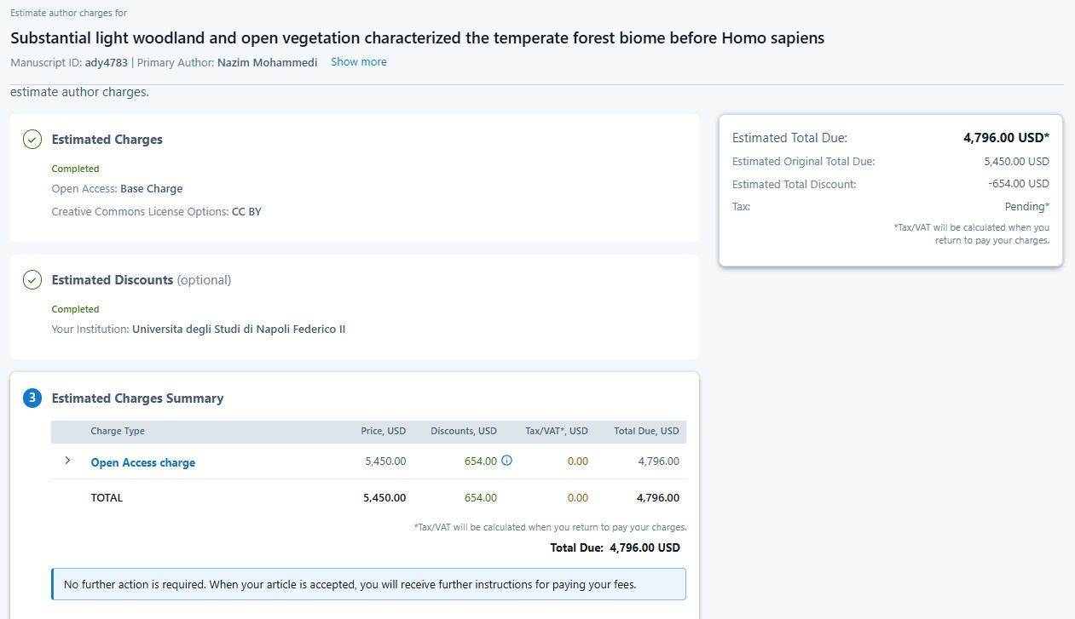

The process is now complete, and the discount will be applied

Author Affiliations in AAAS’s Manuscript Submission System (CTS).

- Each manuscript record contains a list of authors as well as their affiliations. This is the source of the affiliation information used to apply discounts.
  - Note: Depending on the stage of the submission, the view may differ from the screenshots below.
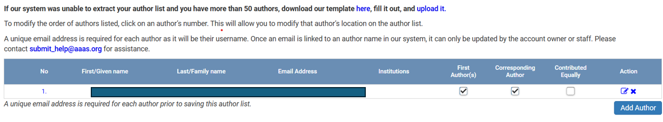

- To add an institution, click the edit icon next to the author’s name.
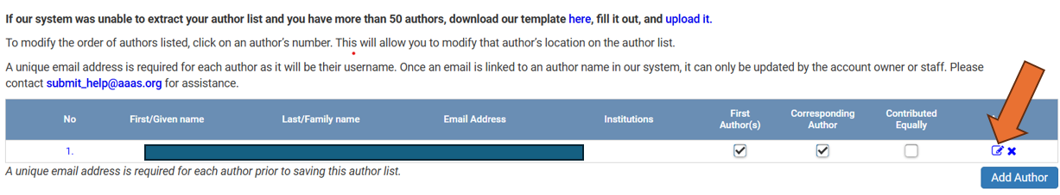

- In the pop-up window that appears, click on the “Select Additional Institution” and then “If you do not see your institution listed, please click here to add a new author institution for this article.”
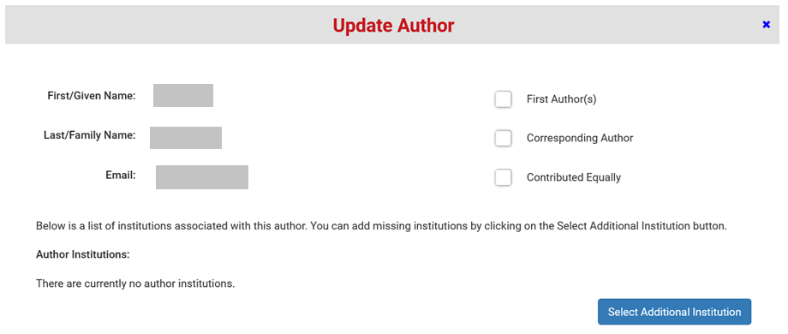
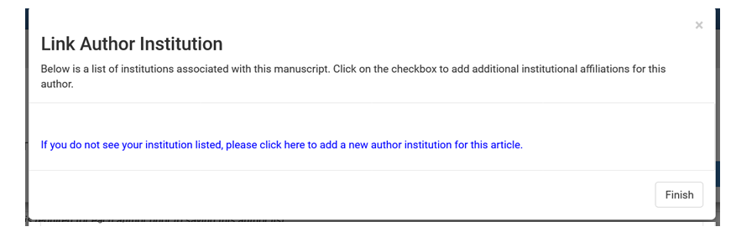
- Search for your institution in the resulting search box, select the correct institution from the search results, and click the “Select” button.
  - Note: Affiliation discounts are based on Ringgold ID so make sure that the Ringgold ID result has been selected.
  - Note: It is possible to successfully search for the organization by its name in different languages and by acronym.

